WEEK 2

TDD using JUnit 5 and Mockito

Exercise 1: Setting Up Junit

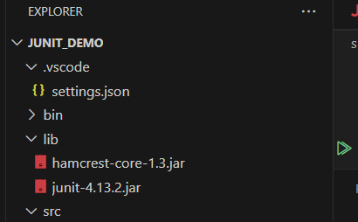

Exercise 2: Writing Basic JUnit Tests

public class Calculator {

    public int add(int a, int b) {

        return a + b;

    }

    public int subtract(int a, int b) {

        return a - b;

    }

}

mport static org.junit.Assert.assertEquals;

import org.junit.Test;

public class CalculatorTest {

    @Test

    public void testAdd() {

        Calculator calc = new Calculator();

        assertEquals(5, calc.add(2, 3));

    }

    @Test

    public void testSubtract() {

        Calculator calc = new Calculator();

        assertEquals(1, calc.subtract(3, 2));

    }

}

OUTPUT

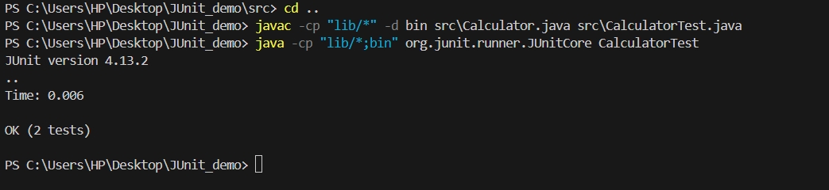

Exercise 3: Assertions in JUnit

import org.junit.Test;

import static org.junit.Assert.\*;

public class AssertionsTest {

@Test

public void testAssertions() {

assertEquals(5, 2 + 3);

assertTrue(5 > 3);

assertFalse(5 < 3);

assertNull(null);

assertNotNull(new Object());

}

}

OUTPUT

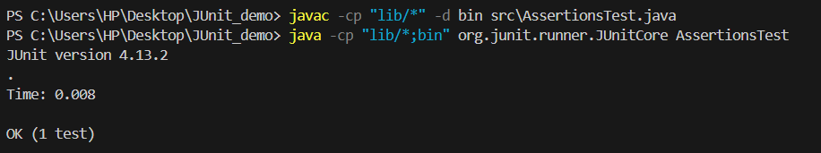

Exercise 4: Arrange-Act-Assert (AAA) Pattern, Test Fixtures, Setup and Teardown Methods in JUnit

public class User {

    String name;

    public User(String name) {

        this.name = name;

    }

    public String greet() {

        return "Hello, " + name;

    }

}

import static org.junit.Assert.assertEquals;

import org.junit.After;

import org.junit.Before;

import org.junit.Test;

public class UserTest {

    User user;

    @Before

    public void setUp() {

        user = new User("Alice"); // Arrange

    }

    @Test

    public void testGreet() {

        String result = user.greet(); // Act

        assertEquals("Hello, Alice", result); // Assert

    }

    @After

    public void tearDown() {

        user = null;

    }

}

OUTPUT

